Assignment 3
Advance HPC Lab
PRATIK ABHANG | 260740150018
AKANKSHA JADHAO | 260740150004

Q1. What is a GPU? Give its uses.
A GPU (Graphics Processing Unit) is a highly parallel processor designed for graphics rendering and general-purpose parallel computing. It accelerates 2D/3D graphics, AI, scientific computing, machine learning, and high-performance computing. GPUs are used in gaming, workstations, data centres, autonomous systems, mobile devices, and supercomputers.

Q2. What is GPGPU computing?
GPGPU means General-Purpose Graphics Processing Unit computing. It uses a GPU for non-graphics scientific and engineering computations. It is useful for computationally intensive, data-parallel tasks where many operations can be performed concurrently.

Q3. Compare CPU and GPU.
Feature | CPU | GPU
Design focus | General-purpose processing and control | High-throughput parallel processing
Parallelism | Typically fewer, more complex cores | Many parallel processing units
Best suited for | Sequential logic and varied tasks | Large data-parallel workloads
Examples of use | Operating systems and program control | Graphics, AI, simulations and matrix operations

Q4. List important components of a typical GPGPU architecture.
The slides list GPU cores, instruction cache, texture units, an interconnect network, streaming multiprocessors (SMs), double-precision units, load/store units, and special-function units.

Q5. Explain the OpenACC execution model.
1. The program starts and runs on the host CPU.
2. The programmer identifies compute-intensive regions that can run in parallel.
3. OpenACC directives tell a supporting compiler which regions and data can be offloaded.
4. Required data is transferred to accelerator memory as directed by the data clauses.
5. The GPU executes the compute kernels.
6. Results are copied back when required, and the host continues execution.

Q6. What is OpenACC? State its benefits.
OpenACC is a directive-based programming model for accelerating C, C++, and Fortran programs on accelerators. The slides describe it as high-level and similar in style to OpenMP directives. Its stated properties include incremental adoption, a single source, interoperability, and performance portability.

Q7. Explain the OpenACC directive syntax.
For C/C++, the general form is:
#pragma acc directive clauses
“#pragma” introduces a compiler directive, “acc” identifies OpenACC, the directive specifies the operation, and clauses add options or details.

Q8. Differentiate between parallel and kernels constructs.
Construct | Meaning in the slides | Typical use
parallel | Programmer asserts that the region is safe and desirable to parallelize; work sharing is specified more explicitly. | When the programmer wants more direct control over parallel work.
kernels | Compiler has more freedom to analyse the region and create kernels; work sharing is determined automatically. | When asking the compiler to find parallelism.

Q9. Write an OpenACC program to add two arrays.
The following is a complete C example using the parallel loop and data-copy pattern illustrated in the lecture slides.
#include <stdio.h>
#define N 10
int main(void) {
int a[N], b[N], result[N];
int i;
for (i = 0; i < N; i++) {
a[i] = i + 1;
b[i] = N - i;
}
#pragma acc data copyin(a[0:N], b[0:N]) copyout(result[0:N])
{
#pragma acc parallel loop
for (i = 0; i < N; i++) {
result[i] = a[i] + b[i];
}
}
for (i = 0; i < N; i++) {
printf("%d + %d = %d\\n", a[i], b[i], result[i]);
}
return 0;
}
Result:
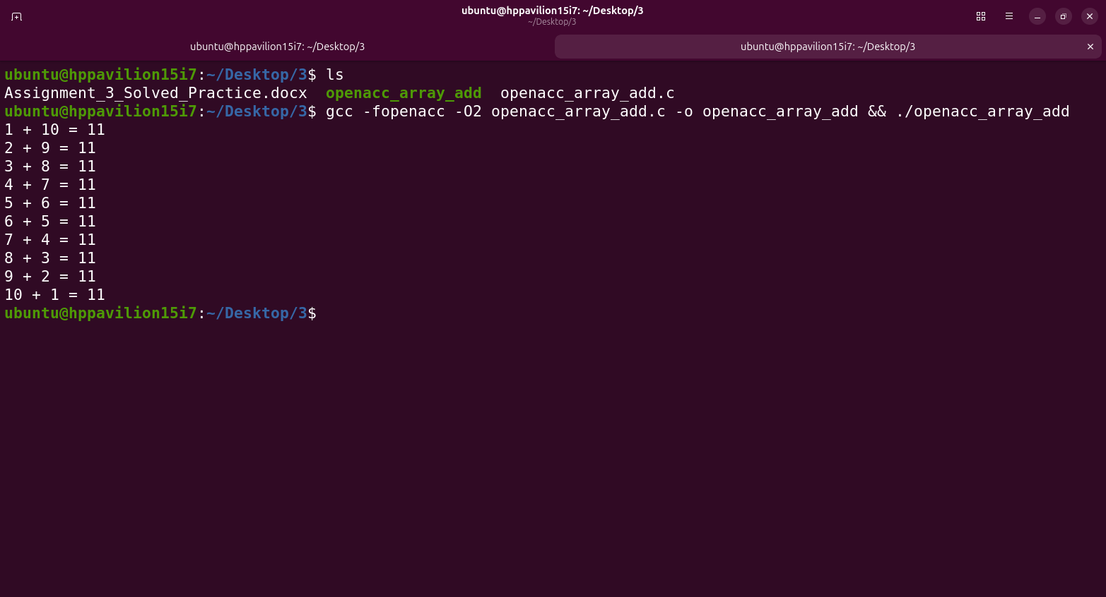

Q10. Explain OpenACC data clauses.
Clause | Purpose described in the slides
copy(list) | Allocates device space, copies data to the device at entry, copies it back at exit, then releases device space.
copyin(list) | Copies data from host to device at entry; does not copy it back at exit.
copyout(list) | Allocates device space without initialising it from the host; copies results back at exit.
create(list) | Allocates device space but does not copy data to or from the device.
present(list) | Indicates the data is already present on the device.
if(condition) | Chooses whether the region is executed on the accelerator or host, according to the condition.
async(expression) | Requests asynchronous execution.
reduction(operator:variable) | Combines private partial values into one final result.

Q11. Why is reduction needed in a parallel loop?
If multiple parallel iterations update the same variable, they can interfere and produce an incorrect result. A reduction gives each parallel worker a private partial value and combines those partial values using the specified operator. For example, reduction(+:sum) computes a sum safely across parallel iterations.

Q12. Explain gang, worker, and vector.
The lecture slides describe gang, worker, and vector as levels of parallelism. A gang contains workers; workers execute on a streaming multiprocessor; vector lanes represent parallel thread execution. The slides note that GPU threads execute in SIMT fashion and describe warps as groups of 32 threads in the context presented.

Q13. Give the OpenACC development cycle.
1. Analyse the program and identify potential parallelism.
2. Parallelize the most time-consuming parts first.
3. Check that results remain correct.
4. Optimize the implementation and measure performance; improvement may not happen all at once.

